Results

1. +1 per step

Training:

Seed: 30

Episodes taken to train: 402

Energy taken to train: 35468.73 J

Seed: 61

Episodes taken to train: 376

Energy taken to train: 60756.88 J

Testing (all other params are 0, theta is varying):

0: Total power – 428.23 J

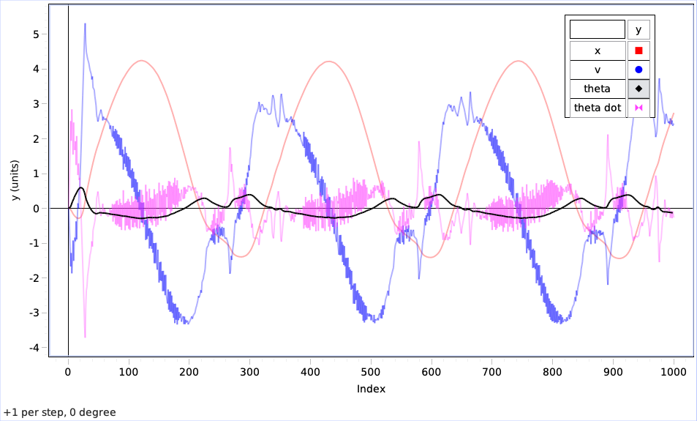

10: Total power – 441.86 J

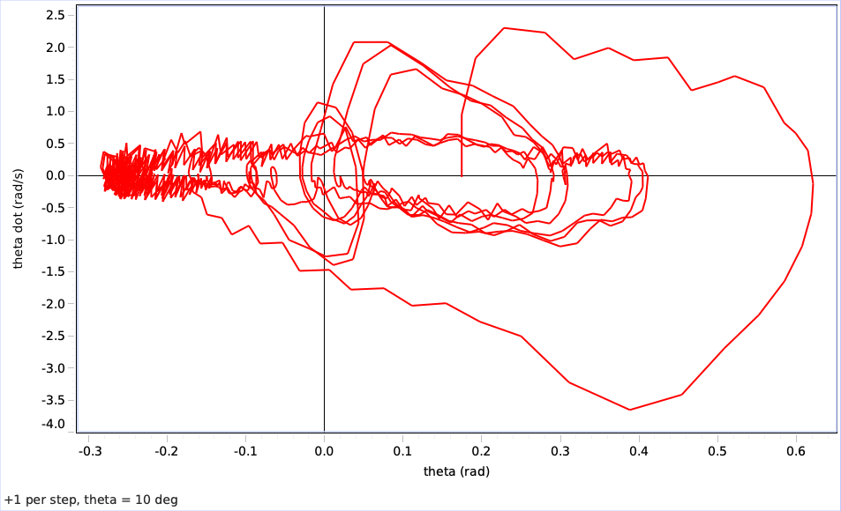

20: Total power – 470.05 J

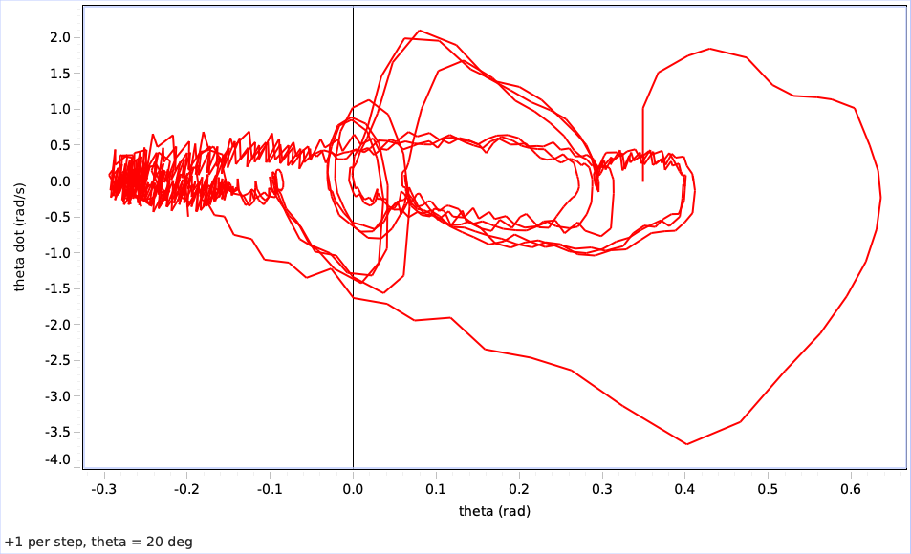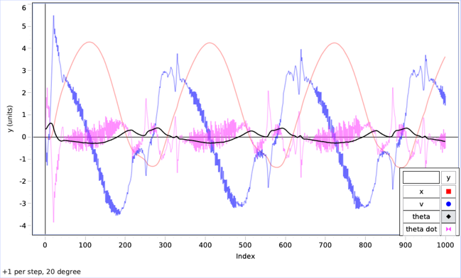  
30: Total power – 455.90 J

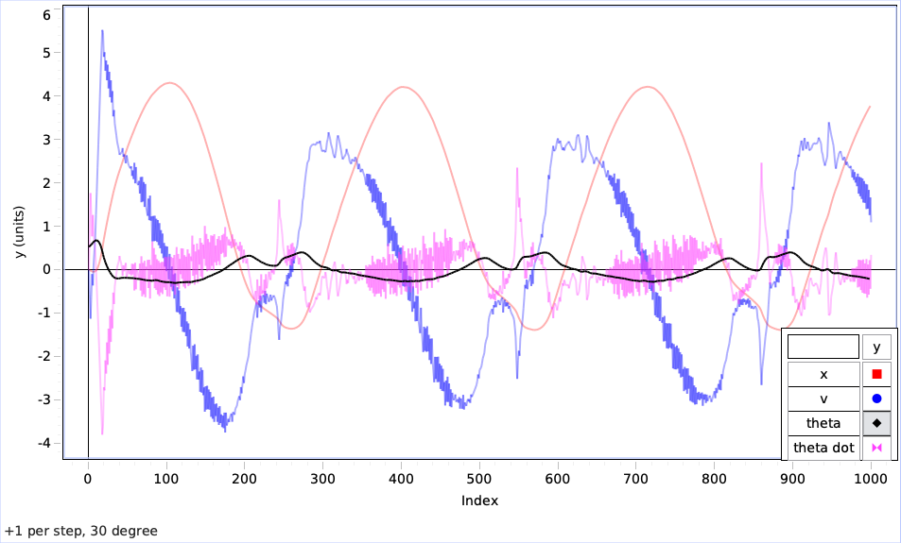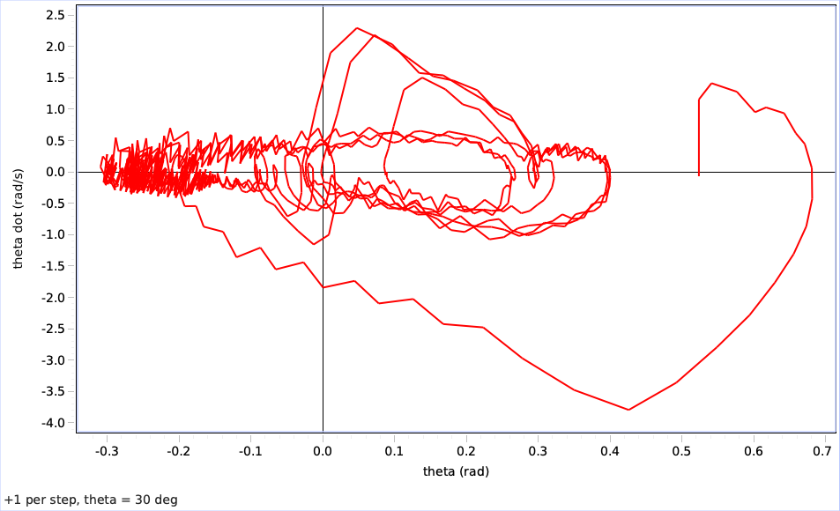

40: Total power - 500.55 J

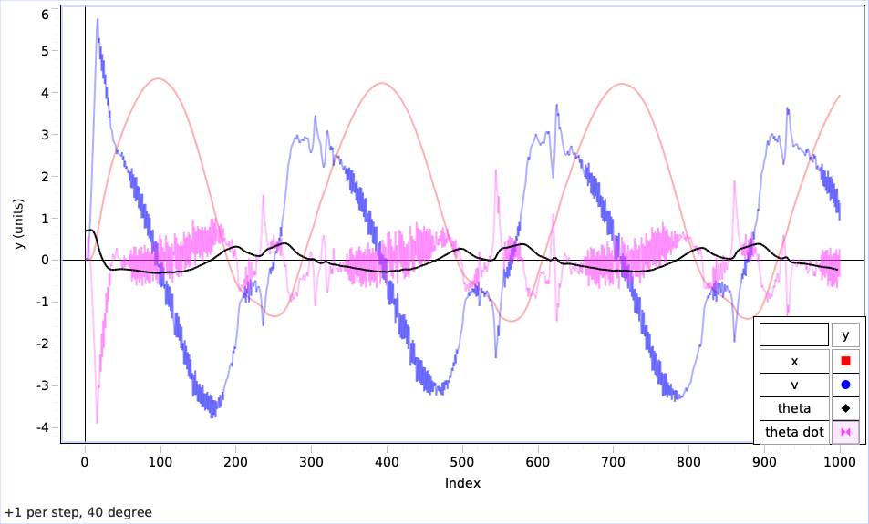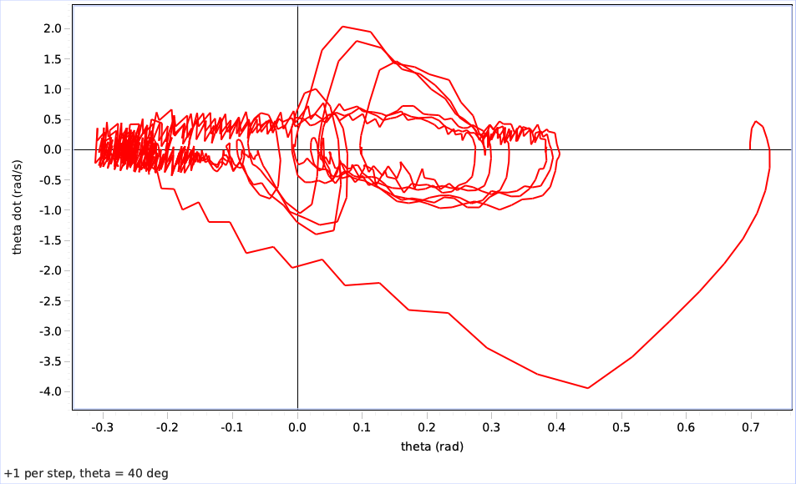

50: Total power – 479.10 J

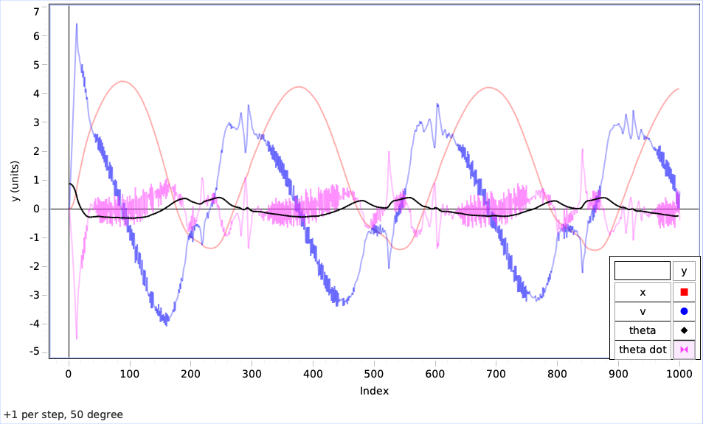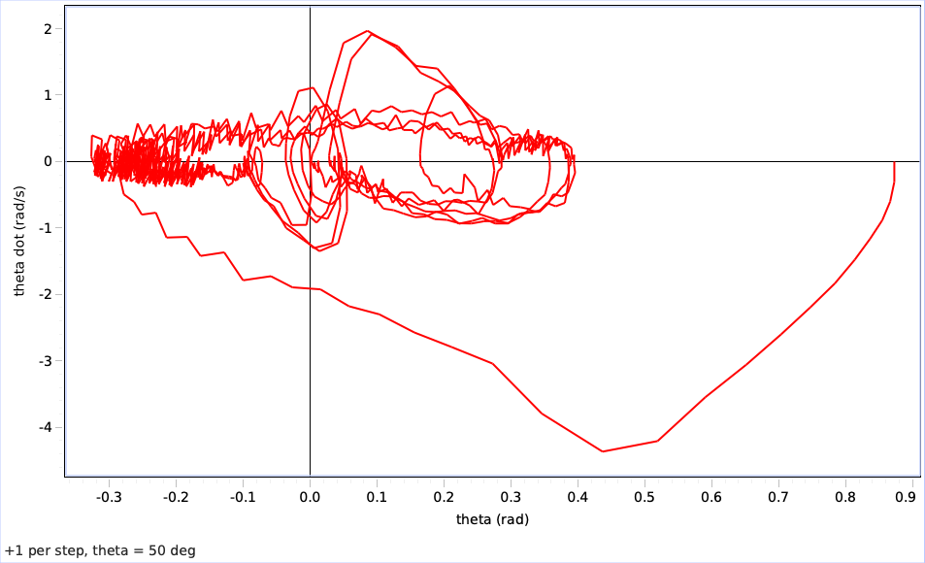

1. (1 + cbf)

Training:

Seed: 30

Episodes taken to train: 537

Energy taken to train: 44275.60 J

Seed: 61

Episodes taken to train: 438

Energy taken to train: 78380.35 J

Testing (all other params are 0, theta is varying):

0: Total power – 9.71 J

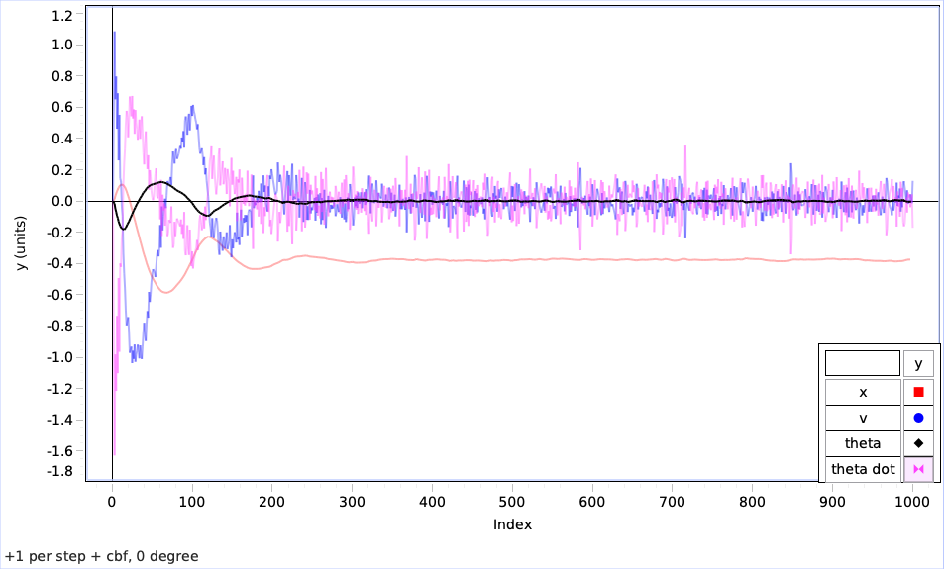

10: Total power – 21.72 J

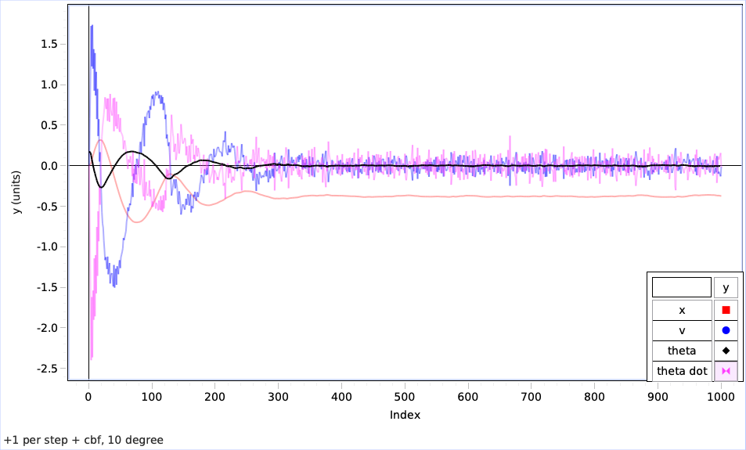 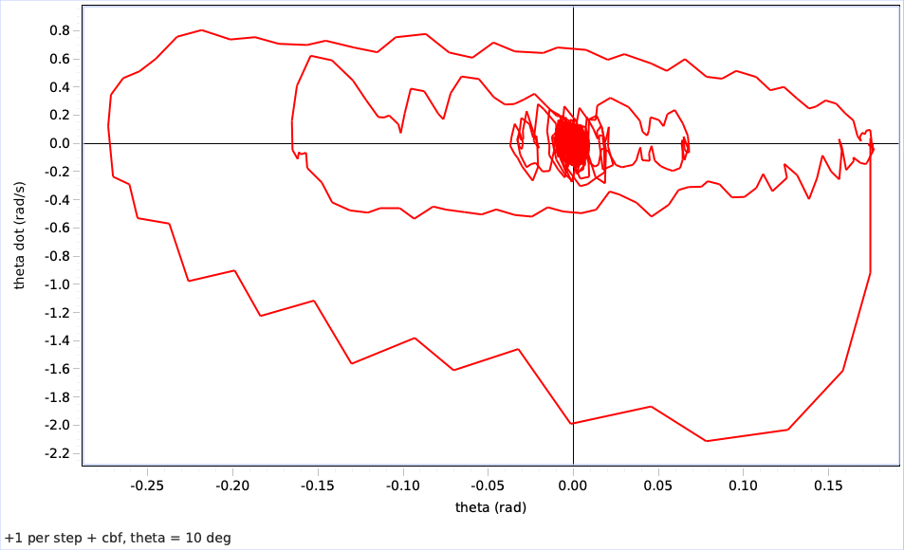

20: Total power – 42.02 J

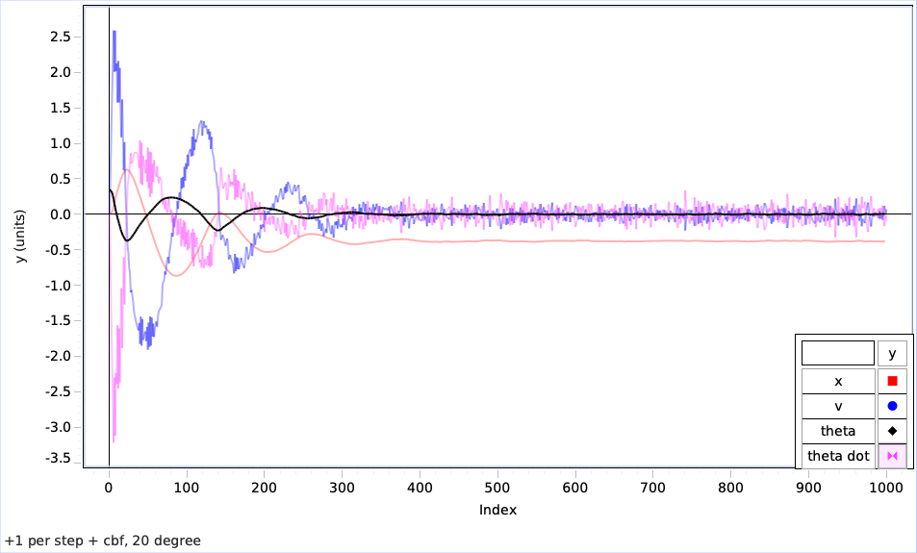 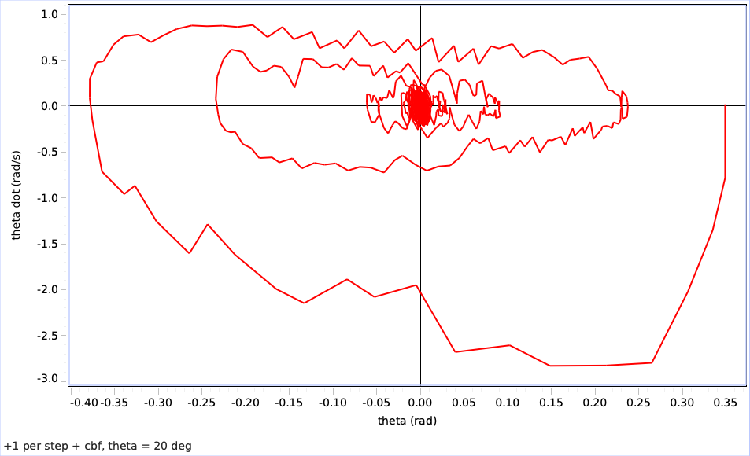

30: Total power – 73.53 J

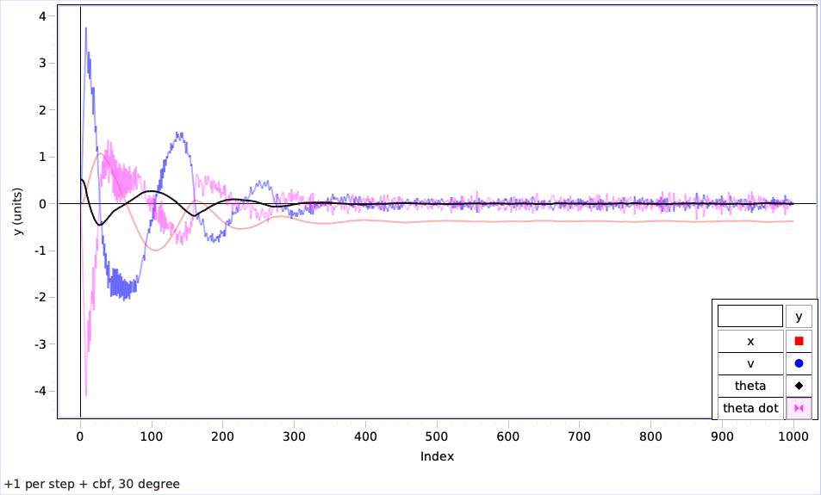 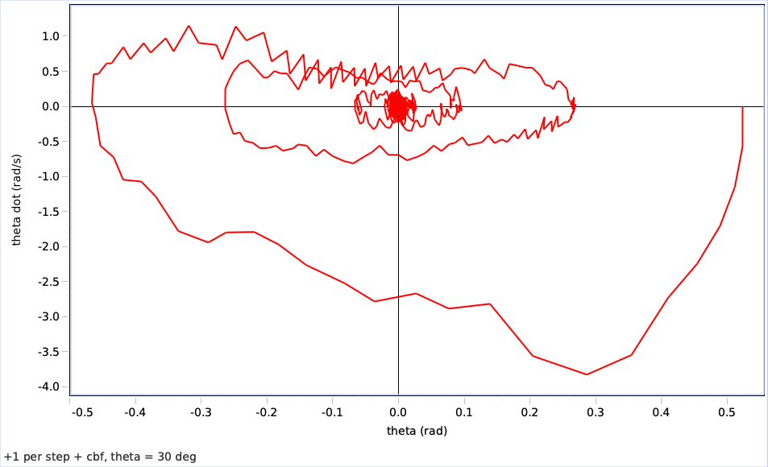

40: Total power – 110.85 J

50: Total power – 180.02 J

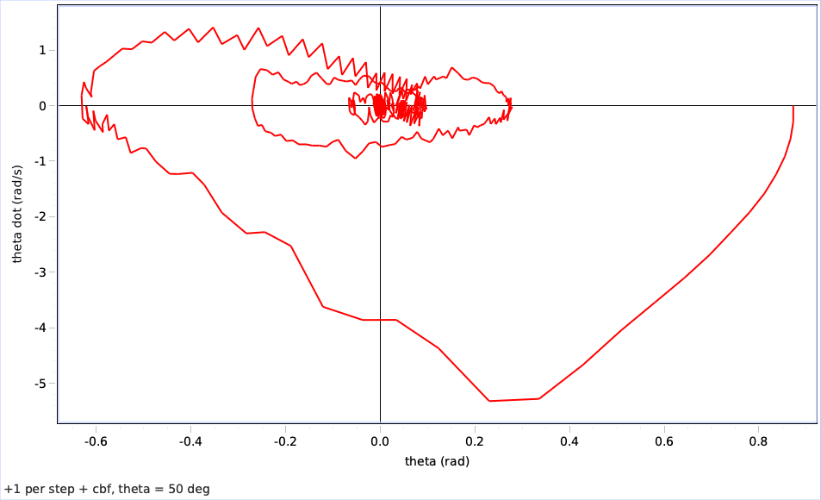

1. (1 + relu cbf)

Training:

Seed: 30

Episodes taken to train: 428

Energy taken to train: 32417.87 J

Seed: 61

Episodes taken to train: 570

Energy taken to train: 32185.60 J

Testing (all other params are 0, theta is varying):

0: Total power – 155.54 J

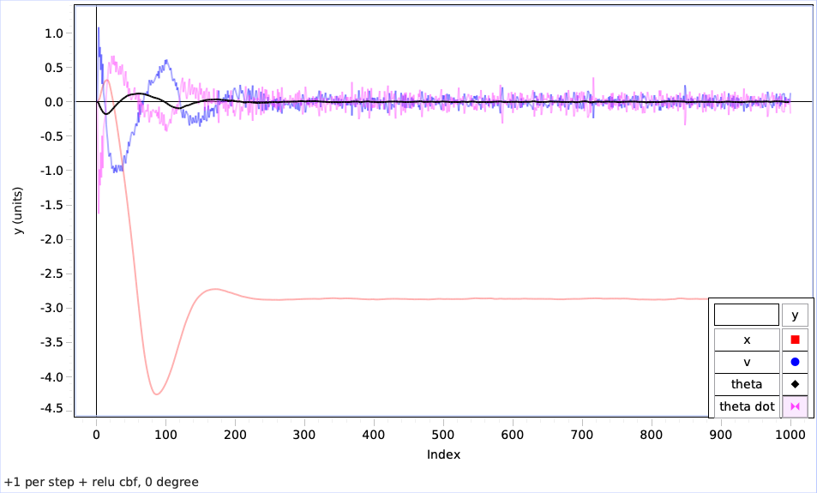

10: Total power - 161.14 J

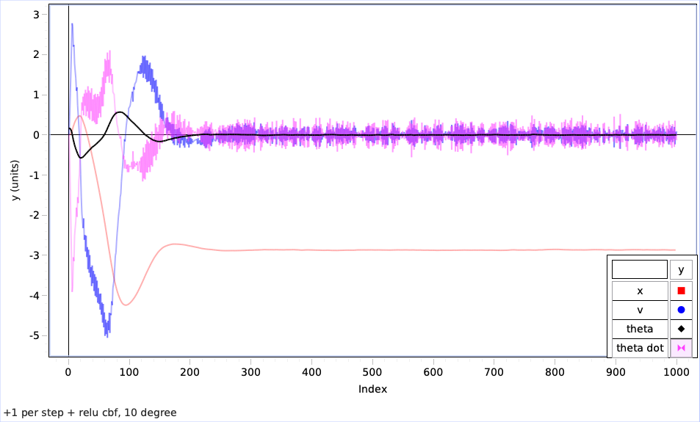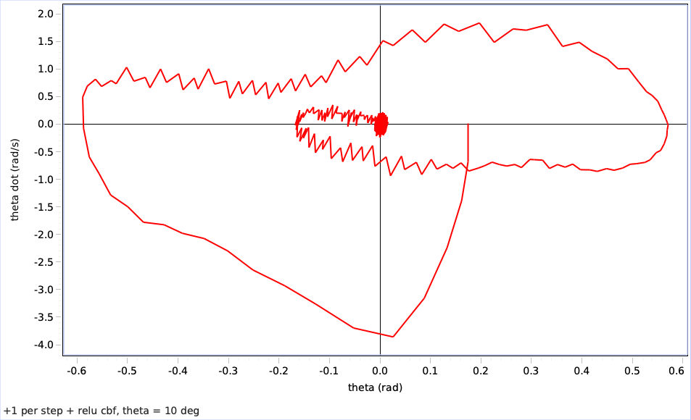

20: Total power – 171.68 J

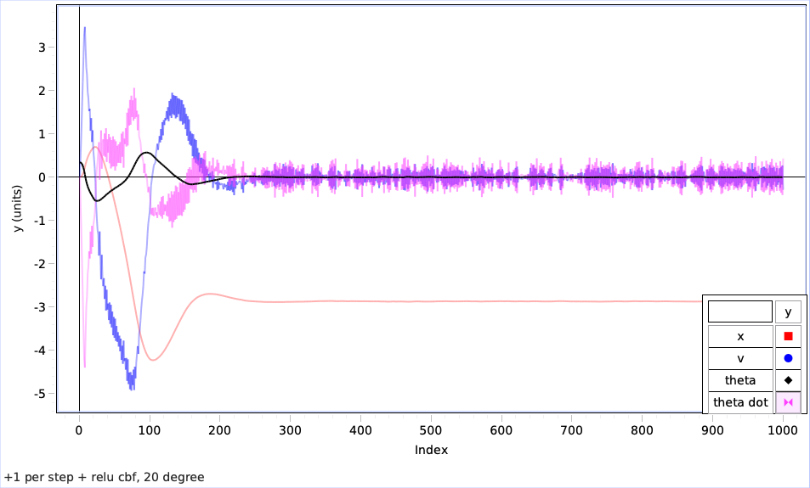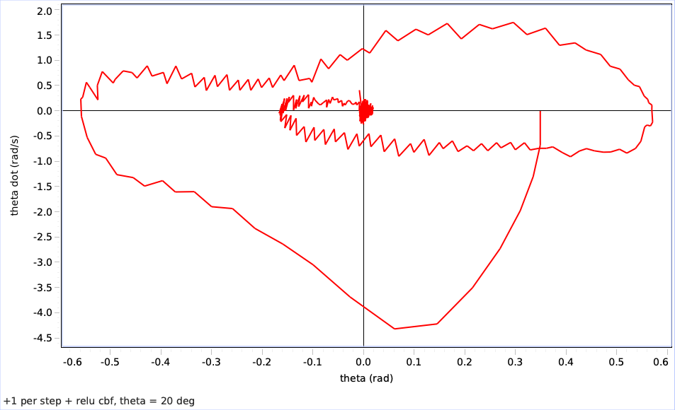

30: Total power - 183.31 J

40: Total power - 258.76 J

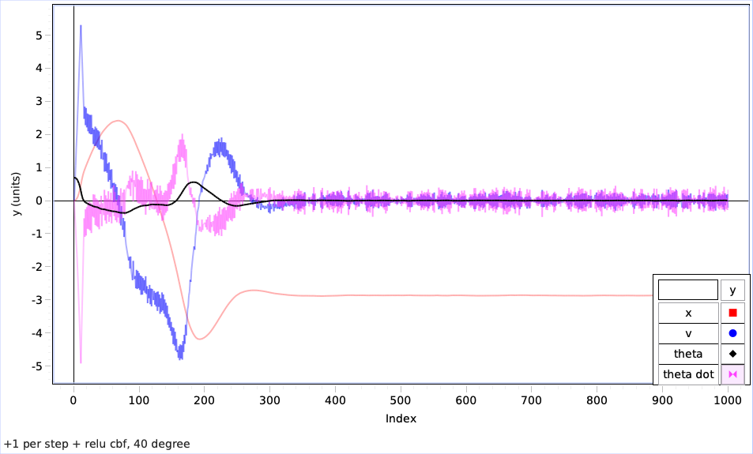

50: Total power - 297.36 J

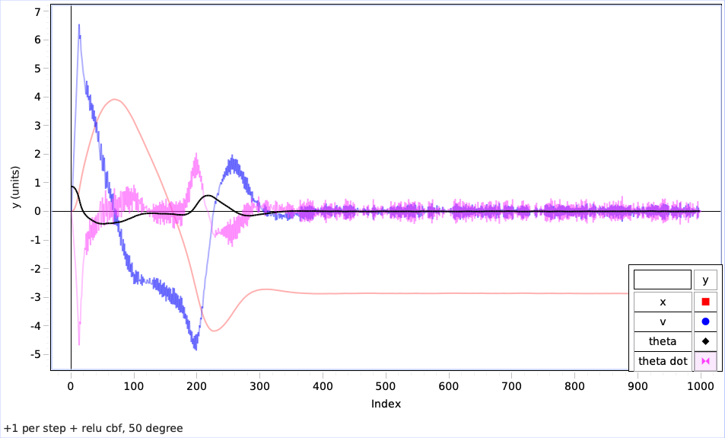

1. (only cbf)

Training:

Seed: 30

Episodes taken to train:

Energy taken to train: J

Seed: 61

Episodes taken to train:

Energy taken to train: J

Testing (all other params are 0, theta is varying):

0: Total power –J